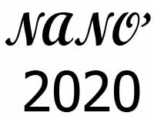
International Conference
“Nanoscale phenomena in low-dimensional structures and novel functional materials:
Quantum transport, energy conversion, material design and device optimization”
08-10 September, 2020
Registration Form
First (given) name:
Surname (family) name:
Gender:
Nationality:
Date of birth:
Current Affiliation:
Position:
Address of affiliation:
E-mail:
University education:
Degree-Specialization:
Area of research:
Specific topic of interest:
Title of the poster presentation (if any)

